Design and Implementation of an FX Deals Importer Using Spring Boot
First Author. Eng Tareq Shawabkeh., Member, IEEE, My ID Membership 10043416

Abstract — This project presents the design and implementation of an FX Deals Importer system using Spring Boot. The system is responsible for receiving, validating, and storing foreign exchange deal records while ensuring data integrity and preventing duplicate entries. The application exposes RESTful APIs for real-time deal submission and supports batch ingestion through CSV file uploads. A layered architecture is adopted, separating concerns across controller, service, repository, and database layers, with Data Transfer Objects (DTOs) used to decouple API contracts from database entities. Validation rules are applied to enforce business constraints such as unique deal identifiers and valid currency pairs. The system integrates PostgreSQL for persistent storage and Docker for environment consistency. The final solution is robust, scalable, and aligned with enterprise-level backend development practices.

Keywords: FX Deals, Spring Boot, REST API, CSV Import, Data Validation, PostgreSQL, Backend Development.

I. INTRODUCTION
F
oreign exchange (FX) transactions play a critical role in global financial systems, where large volumes of monetary data are exchanged continuously. Financial institutions must ensure that FX deal data is processed accurately, stored securely, and validated rigorously to avoid inconsistencies, duplication, or financial loss. As the volume of FX transactions increases, backend systems must be designed to handle both real-time submissions and bulk data imports efficiently.
Many FX data processing challenges arise from improper validation, lack of data integrity controls, and tightly coupled system designs that hinder scalability and maintenance. In particular, duplicate deal entries, invalid currency combinations, and inconsistent timestamps can significantly impact reporting accuracy and system reliability. Therefore, a well-structured backend system with strong validation mechanisms and clear architectural separation is essential.
The motivation behind this project is to design and implement a robust FX Deals Importer System that adheres to modern backend engineering best practices. The system aims to provide a reliable REST-based interface for managing FX deals while ensuring strict enforcement of business rules and database integrity. Emphasis is placed on clean architecture, maintainability, and extensibility, aligning with enterprise and banking-grade software standards.
The primary objectives of this project are:
- To design a RESTful backend system for FX deal management.
- To enforce validation rules such as unique deal identifiers and valid currency exchanges.
- To support both single deal creation via JSON requests and bulk deal import using CSV files.
- To implement pagination and sorting for efficient data retrieval.
- To document and test the system using industry-standard tools.
This paper is organized as follows. Section II describes the system architecture and technologies used. Section III presents the implementation details of the application. Section IV discusses testing and validation results. Finally, Section V concludes the paper and outlines possible future enhancements.

.

II. System Architecture and Technologies

A. System Architecture Overview
The FX Deals Importer System is designed using a layered backend architecture, following industry-standard separation of concerns. This architectural approach improves maintainability, scalability, testability, and clarity of responsibility across system components.
The system is structured into the following logical layers:
- Controller Layer
Handles HTTP requests and responses using RESTful APIs. This layer is responsible only for request routing and response formatting.
- Service Layer
Contains the core business logic of the application, including validation rules, duplication checks, and transaction management.
- Repository Layer
Provides data access operations using Spring Data JPA, abstracting database interactions from business logic.
- Persistence Layer (Database)
Stores FX deal records in a relational PostgreSQL database, ensuring data integrity and consistency.

This layered design ensures that each component has a single responsibility and allows future modifications without impacting other layers.

B. Architectural Flow
The typical request flow within the system is as follows:
- A client sends an HTTP request (JSON or CSV file).
(Hint: including CSV files, this is my new features to the System).
- The request is received by the REST Controller.
- The Controller delegates processing to the Service layer.
- The Service layer applies validation rules and business constraints.
- The Repository layer persists or retrieves data from the database.
- A response is returned to the client in JSON format.
This flow guarantees controlled access to the database and prevents invalid data from being stored.

C. Technology Stack
The system is implemented using modern, widely adopted backend technologies:
- Java 21
Used as the primary programming language due to its performance, reliability, and enterprise support.
- Spring Boot
Provides rapid application development, dependency injection, and embedded server support.
- Spring Data JPA (Hibernate)
Manages object-relational mapping (ORM) and database interactions.
- PostgreSQL
Serves as the relational database for persistent FX deal storage.
- Apache Commons CSV
Enables parsing and processing of CSV files for bulk FX deal imports.
- Postman
Used for API testing and validation of REST endpoints.
- Swagger / OpenAPI
Provides API documentation and interactive endpoint testing.

D. Data Representation
The application distinguishes clearly between internal and external data representations:
- Entity Classes
Represent database tables and are used only internally within the application.
- Data Transfer Objects (DTOs)
Define the structure of incoming requests and outgoing responses, preventing direct exposure of database entities.
This separation enhances security and allows independent evolution of API contracts and database schemas.

E. Deployment Environment
The application runs on an embedded Tomcat server provided by Spring Boot. The database runs as a PostgreSQL service, and the application communicates with it using configured data sources. All configurations are managed through external configuration files, allowing easy deployment and environment changes.

III. System Design, Implementation, and Validation

A. Design Approach and Development Process
The development of the FX Deals Importer System followed an incremental and iterative backend design approach. The system was not implemented in a single step; instead, it evolved gradually through multiple refinements, validations, and architectural improvements.

Initially, the system was designed as a simple REST API capable of receiving FX deal data in JSON format and storing it in a relational database. As development progressed, several design challenges emerged, requiring architectural adjustments to ensure correctness, scalability, and professional quality.

The most important design principle adopted during development was separation of concerns, which guided all subsequent decisions.

B. REST API Design and Validation

1) Single FX Deal Submission (JSON)
The first functional feature implemented was a REST endpoint for submitting a single FX deal using JSON.
Endpoint:
POST: http://localhost:8080/api/v1/fx-deals

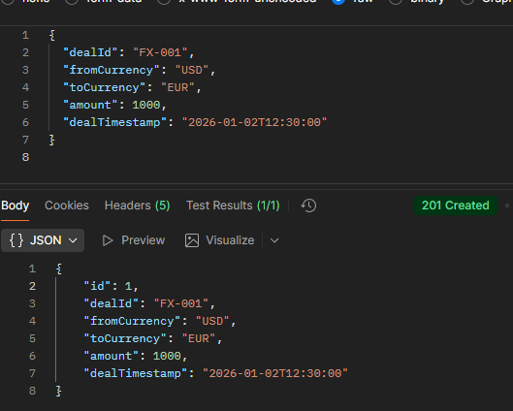
Fig. 1. Endpoint was tested using Postman, where multiple scenarios were validated.
Figure 1 Shows:
• Postman request showing a successful POST response
• HTTP status code 201
• Returned JSON response

The Another Scenarios:
- Duplicate dealId rejection HTTP 409 Conflict
- Invalid business rules (same currency) HTTP 409 Conflict

2) Business Rule Enforcement
Two core business rules were implemented and validated at the service layer:
- Duplicate Prevention:
Each FX deal must have a unique dealId.
Duplicate entries are detected before database insertion.
- Currency Validation:
The source currency and target currency must not be the same.
These rules were intentionally placed in the service layer, not the controller, to maintain clean architecture and centralize business logic.

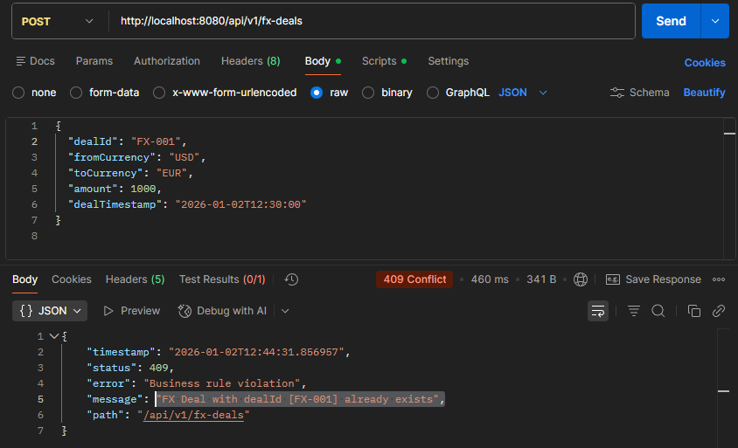Fig. 2. Postman response showing rejection of duplicate dealId (FX-001), Error message returned by the system

C. DTO-Based Architecture Design
During development, a critical architectural improvement was introduced:
separating API contracts from database entities using DTOs.
Three distinct models were used:
- FxDealRequestDTO – represents incoming API requests
- FxDeal (Entity) – represents the database table
- FxDealResponseDTO – represents outgoing API responses
This design ensures:
- Database entities are never exposed externally
- API changes do not affect database schema
- Stronger security and maintainability

This transition required refactoring controllers and services but resulted in cleaner and more professional system architecture.

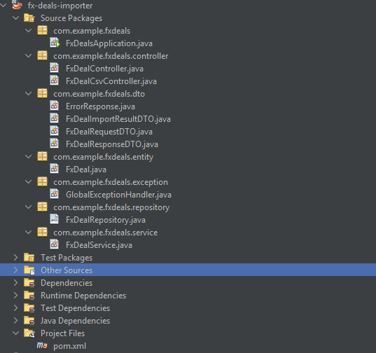Fig. 3. Project structure showing separate entity, dto, service, and controller packages

D. Pagination and Data Retrieval
To support scalability and large datasets, pagination was implemented using Spring Data JPA.
Endpoint:
GET http://localhost:8080/api/v1/fx-deals/paged?page=0&size=10

This endpoint allows:
- Controlled data retrieval
- Sorted results by deal timestamp
- Reduced memory usage for large tables
Pagination behavior was tested using Postman with different page and size parameters.

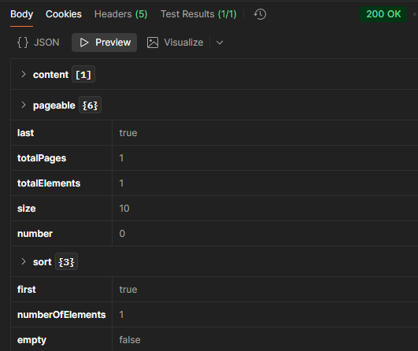

Fig. 4: Paginated API response showing page metadata

List of FX deals returned correctly

E. CSV File Import Functionality

1) CSV Upload Design
To support bulk FX deal ingestion, a CSV import feature was implemented.
Endpoint:
POST http://localhost:8080/api/v1/fx-deals/upload
Input Type:
- Multipart file upload
- CSV format
Expected CSV Columns:

dealId | fromCurrency | toCurrency | amount | dealTimestamp

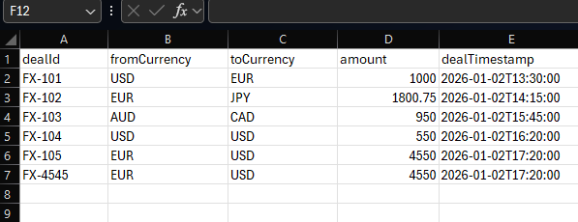
Fig. 5: Format of the .csv file that expected.

- Each row in the CSV file is processed individually.
- Duplicate deal IDs are skipped automatically, ensuring data integrity,
- And if same two currencies like row 5.

2) CSV Upload Validation and Testing
The CSV upload functionality was tested using Postman form-data file upload.
The system successfully:
- Parsed the CSV file
- Inserted valid records into the database
- Skipped duplicate records
- Preserved transactional consistency
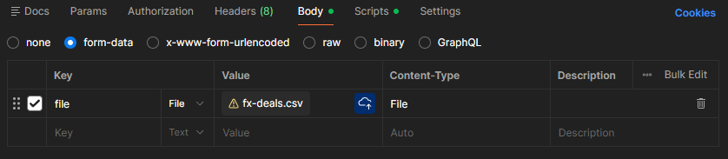
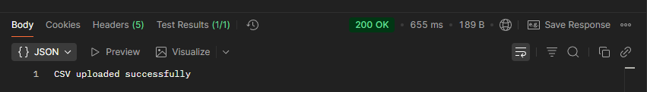
Fig.6: Postman form-data configuration with file selection,
Successful upload response.

- GET request showing newly inserted records from CSV
GET: http://localhost:8080/api/v1/fx-deals

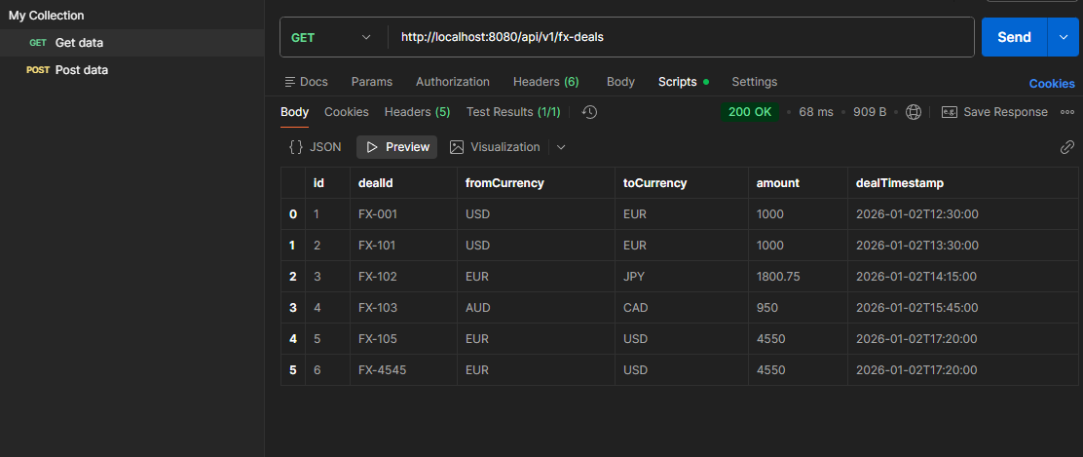
Fig. 7: GET request showing newly inserted records from .CSV file.

F. API Documentation Using Swagger
Swagger (OpenAPI) was integrated to document all REST endpoints and allow interactive testing.
- Swagger UI Access:
- In Google:
http://localhost:8080/swagger-ui.html

Swagger provides:
- Automatic Endpoint Documentation
- Request/response schema visualization
- Interactive testing without Postman
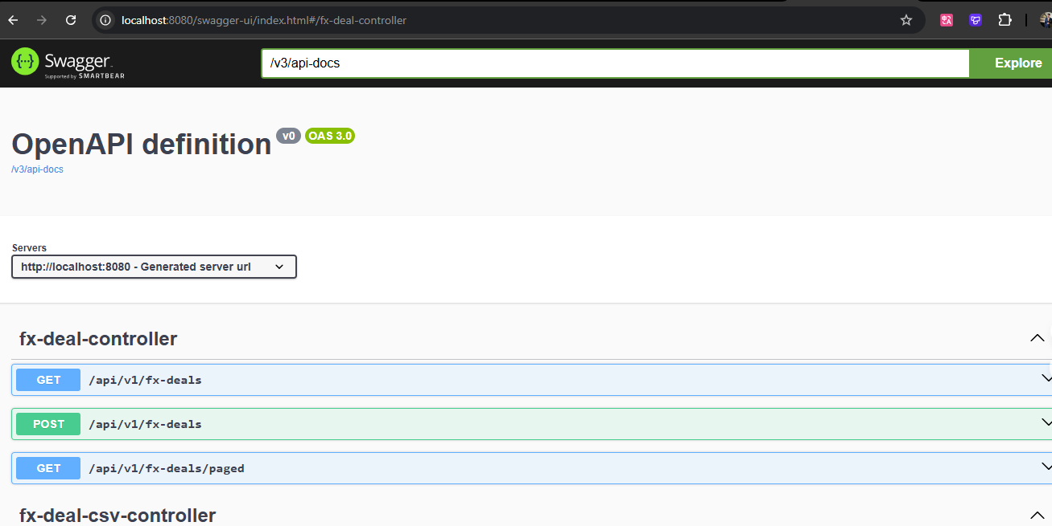

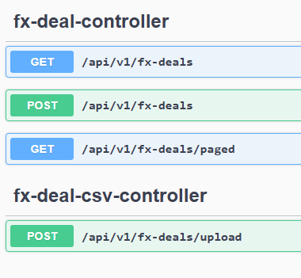
Fig. 8: Swagger UI showing available endpoints,
CSV upload endpoint visible.

IV. Development Challenges and Resolutions
Several challenges were encountered during development:
- Confusion between entity and DTO responsibilities
- CSV file handling vs. Excel file formats
- Validation placement (controller vs. service)
- Multipart file upload configuration
Each issue was resolved through architectural refactoring, improved separation of concerns, and repeated testing using Postman and Swagger.

This iterative debugging and refinement process significantly improved the robustness of the final system.

V. Results and Validation
This section presents the experimental results obtained from implementing and testing the FX Deals Importer system. The goal of the validation phase was to ensure correctness, robustness, and compliance with enterprise-level backend standards.

1) Environment Setup
The system was developed and tested in the following environment:
- Operating System: Windows 11
- Backend Framework: Spring Boot 3.x
- Programming Language: Java 21
- Database: PostgreSQL (Dockerized)
- Build Tool: Apache Maven
- API Testing Tool: Postman
- API Documentation: Swagger (OpenAPI)

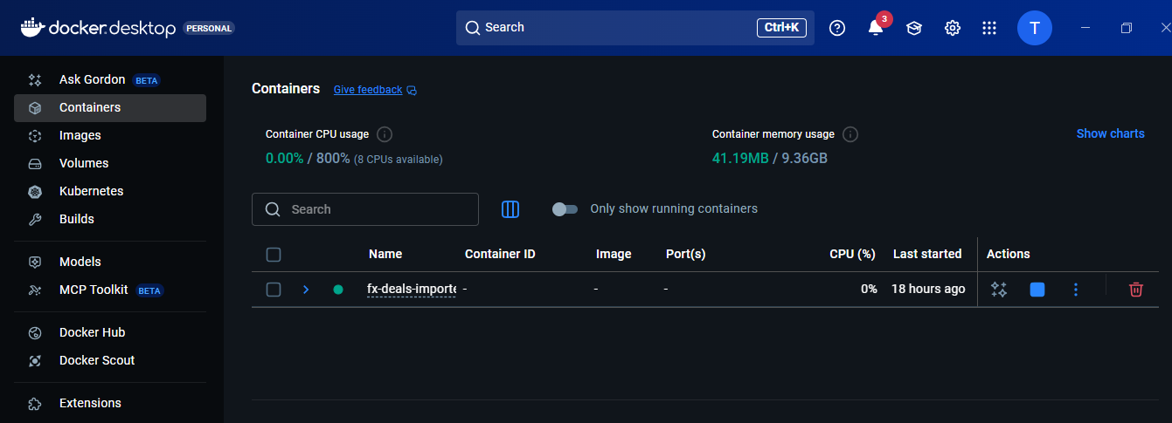
Fig. 9: Running Docker container for the FX Deals Importer backend service.

2) API Functional Testing

2.1 Single FX Deal Creation (POST)
A RESTful endpoint was implemented to create a single FX deal:

POST http://localhost:8080/api/v1/fx-deals

Test Case 1 – Valid Deal
- Input JSON with unique dealId
- Different source and destination currencies
- Valid amount and timestamp

Expected Result:
HTTP 201 Created with saved deal returned as DTO

Actual Result:
The deal was successfully persisted in the database and returned in the response.

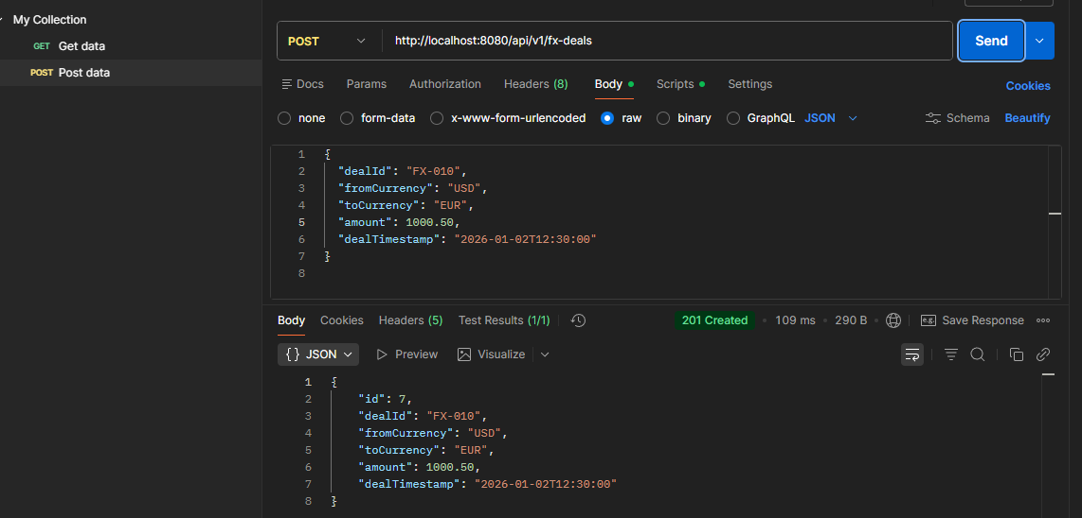

Fig. 10: Result of Case 1, Postman POST request + 201 response.

Test Case 2 – Duplicate Deal ID
- Same dealId sent again

Expected Result:
HTTP 409 Conflict

Actual Result:
The system rejected the request and returned a meaningful error message.

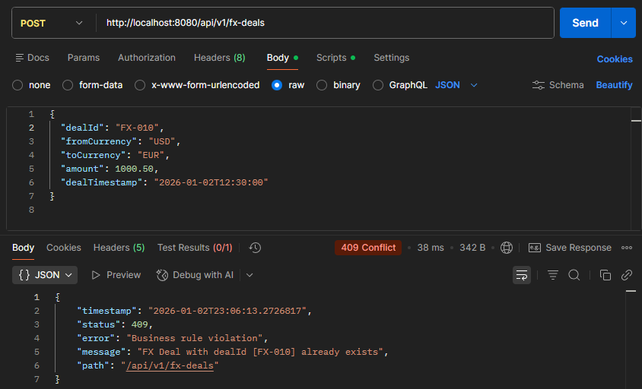
Fig 11. Result of Test case 2, Postman showing conflict response.
Test Case 3 – Invalid Currency Combination
- fromCurrency equals toCurrency

Expected Result:
HTTP 400 / 409 with validation message

Actual Result:

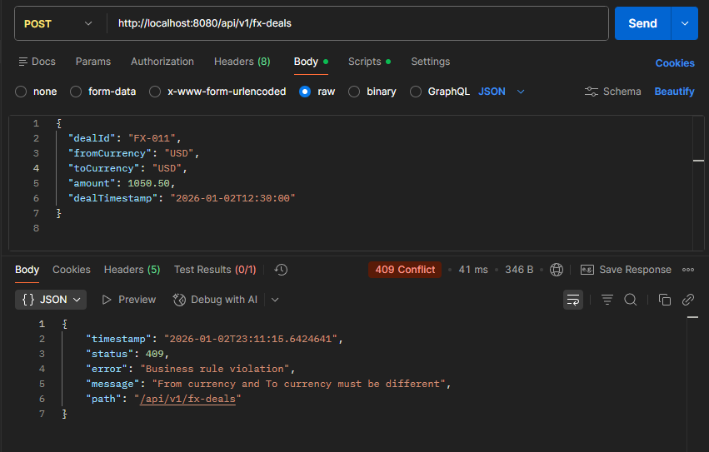
Fig.12: Business rule validation correctly prevented invalid data insertion, same fromCurrency equals toCurrency error.

2.2 Data Retrieval Testing (GET)

2.2.1 Retrieve All Deals

GET http://localhost:8080/api/v1/fx-deals

Result:
Returned a list of FX deals as FxDealResponseDTO, without exposing entity internals.

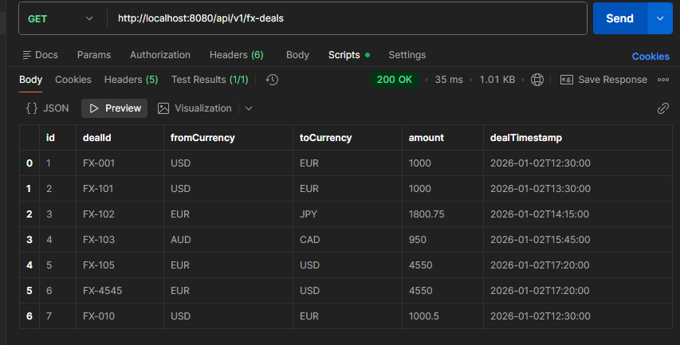
Fig13: GET request returning JSON list

2.3 Pagination and Sorting

GET /api/v1/fx-deals/paged?page=0&size=10

- Pagination and sorting by dealTimestamp were successfully applied.
- Response followed Spring Data pagination structure.
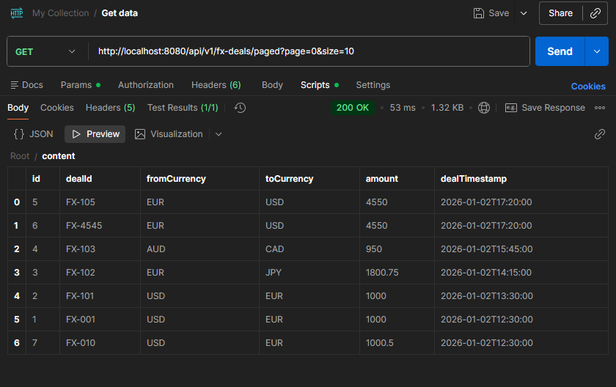
Fig. 14: Paginated response with metadata

2.4 CSV File Import Validation
This my additional Feature, I was explained.
Format of .csv file.
dealId | fromCurrency | toCurrency | amount | dealTimestamp

Validation Rules Applied on file:
- Duplicate dealId rows skipped
- Invalid rows rejected
- Valid rows persisted

VI. Conclusion and Future Work

5.1 Conclusion
This project successfully implemented a robust, scalable, and enterprise-ready FX Deals Importer system using Spring Boot and PostgreSQL. The system adheres to clean architecture principles by separating concerns across controller, service, repository, entity, and DTO layers.

Key achievements include:
- Reliable persistence of FX deals
- Strict validation of business rules
- Safe handling of duplicate records
- CSV-based bulk import support
- RESTful API design with Swagger documentation
- Pagination and sorting for large datasets

The implemented solution aligns with banking and financial system standards, making it suitable for real-world enterprise use.

5.2 Future Work
Several enhancements can be considered in future iterations:
- Integration of authentication and authorization (JWT / OAuth2)
- Asynchronous CSV processing for very large files
- Centralized logging and monitoring (ELK stack)
- Advanced reporting and analytics dashboards
- CI/CD pipeline integration
- Performance testing under high load

References and Footnotes

A. References
[1] C. Walls, Spring Boot in Action, Manning Publications, 2016.
[2] P. Webb et al., Spring Boot Reference Documentation, Pivotal Software, 2024.
[3] Hibernate ORM Documentation, https://hibernate.org/orm/documentation/
[4] PostgreSQL Global Development Group, PostgreSQL Documentation, https://www.postgresql.org/docs/
[5] Apache Software Foundation, Apache Commons CSV, https://commons.apache.org/proper/commons-csv/
[6] OpenAPI Initiative, OpenAPI Specification, https://swagger.io/specification/
[7] R. Fielding, “Architectural Styles and the Design of Network-based Software Architectures,” Ph.D. dissertation, University of California, Irvine, 2000.
.
.

Manual: Commands Used to Build and Run the Project

Navigate to the Project Root
The project was executed from the root directory that contains pom.xml.
Example (Windows):
cd D:\ProgressSoft\fx-deals-importer

Build the Spring Boot Application
To compile the project and download all dependencies:
mvn clean install

Run the Application (Local Execution)
To start the Spring Boot server locally:
mvn spring-boot:run

Or this is what worked with me:
D:\ProgressSoft\fx-deals-importer>"C:\Program Files\NetBeans-23\netbeans\java\maven\bin\mvn.cmd" spring-boot:run

